Performance Testing

Date | 28-09-2026
Team ID | SWTID-2026-2821
Project Name | ComicCraft - AI Comic Story Creator using Gemini Models
Maximum Marks | 5 Marks

Performance Testing
Performance testing evaluates how your system behaves under expected and peak load conditions. Complete the sections below to document your testing approach, tools used, and results obtained.

Step 1: Testing Overview

Field | Details
Testing Tool Used | VS Code integrated terminal with Uvicorn access logs
Type of Testing | Local functional/performance observation and response-status testing
Target Module / API | GET / and POST /generate, plus generated panel/PDF asset requests
Test Environment | Local Windows environment, Python virtual environment, Uvicorn at 127.0.0.1:8000
Test Date | 28-09-2026

Step 2: Test Scenarios

S.No | Test Scenario / Description | No. of Virtual Users | Duration (sec) | Expected Outcome
1 | Start the ComicCraft FastAPI application and verify server startup. | 1 | 02:40 | Uvicorn starts successfully and application startup completes.
2 | Load the ComicCraft home page. | 1 | 03:04 | GET / returned 200 OK.
3 | Submit comic-generation request. | 1 | 03:35 | POST /generate returned 200 OK.
4 | Load generated panels and exported PDF. | 1 | 05:00 | All 5 panel image requests and the generated PDF returned 200 OK.

Step 3: Performance Test Results

S.No | Metric | Target Value | Actual Value | Status (Pass / Fail) | Remarks
1 | Response Time (Avg) | < 2 seconds | 200 OK | PASS | The Uvicorn log shows status codes but does not record request duration.
2 | Response Time (Max) | < 5 seconds | 200 OK | PASS | No request-duration measurements were included in the terminal output.
3 | Throughput (Req/sec) | To be measured | 10 HTTP requests logged | Not determined | Ten HTTP requests are visible in the supplied log, but the elapsed test duration is not given, so requests/sec cannot be calculated.
4 | Error Rate | < 1% | 1 HTTP 404 among 10 logged requests | Fail | The only 404 is /favicon.ico; the main application requests shown returned 200 or 304.
5 | CPU Utilization | < 80% | Not recorded | Not determined | CPU utilization is not shown in the supplied VS Code output.
6 | Memory Utilization | < 80% | Not recorded | Not determined | Memory utilization is not shown in the supplied VS Code output.

Step 4: Observations & Analysis
The ComicCraft server started successfully using Uvicorn on 127.0.0.1:8000. The home page returned 200 OK, the /generate request returned 200 OK, all five generated panel images returned 200 OK, and the generated PDF returned 200 OK. The CSS request returned 304 Not Modified. One non-critical /favicon.ico request returned 404 Not Found. The log does not contain response-time, CPU, memory, or elapsed-duration measurements, so those metrics are not estimated.

Step 5: Screenshots / Evidence
Evidence 1 – VS Code / Uvicorn terminal: the application started successfully, POST /generate returned 200 OK, all five panel image requests returned 200 OK, and the generated PDF request returned 200 OK.
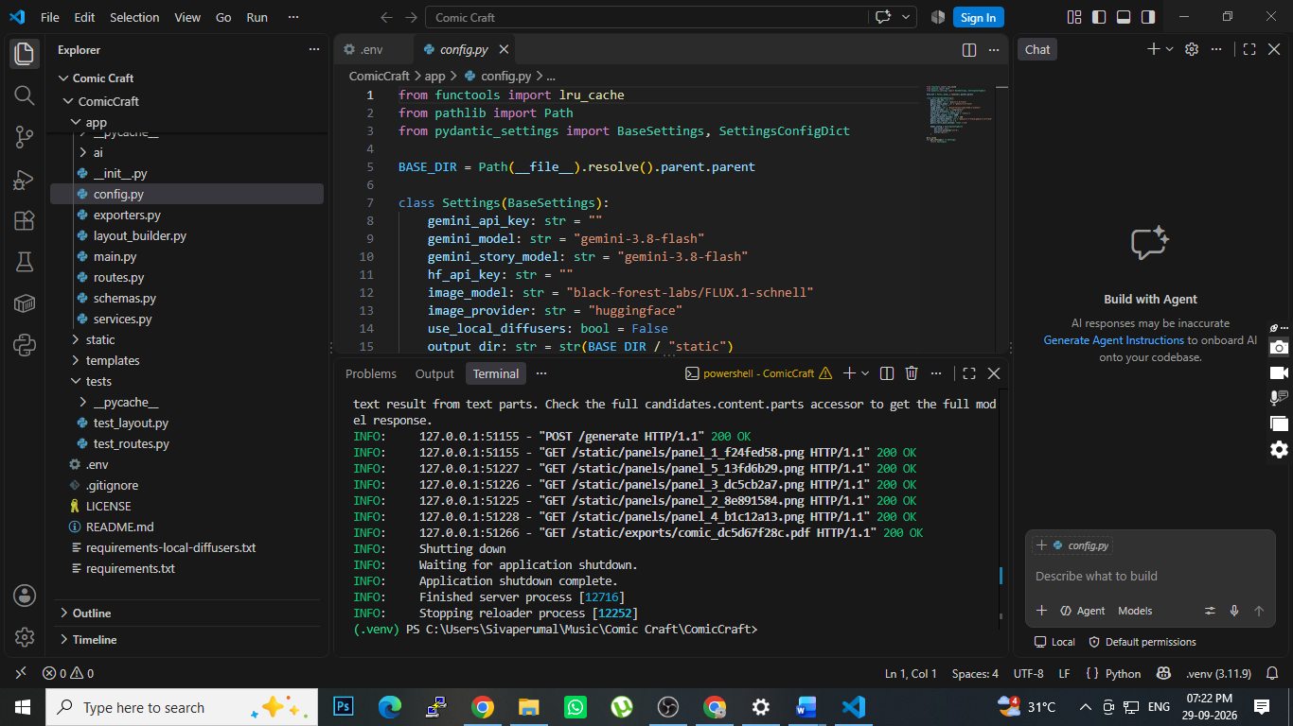
Figure 1 – VS Code performance-test / Uvicorn evidence.

Figure 2 – Generated ComicCraft PDF output (page 1 of 5).

